

**Ahsanullah University of Science and Technology (AUST)**

Department of Computer Science and Engineering

**Offline 1**

Course No.: CSE4126

Course Title: Distributed Database Systems Lab

**Date of Submission-**

16/05/2023

**Submitted To-**

Ms. Zarin Tasnim Shejuti & Ms. Sanzana Karim Lora

**Submitted By-**

MD Fardin Jaman Aranyak

190204093

B2

Year- 4th

Semester-1st

Department-CSE

**Consider the following database schema maintained at a music recording company:**

**Artist(artistID: integer, name: string, age: integer, gender: string)**

**Album(albumID: integer, albumTitle: string, artistID: integer, certification: string,**

**numberOfTracks: integer)**

**Track(trackID: integer, trackTitle: string, genre: string, albumID: integer, published: date)**

**Create the three tables and insert necessary data in the tables using SQL commands**

**Solution:**

CREATE TABLE Artist(

artistID NUMBER PRIMARY KEY,

name VARCHAR2(200),

age NUMBER,

gender VARCHAR2(200)

);

CREATE TABLE Album(

albumID NUMBER PRIMARY KEY,

albumTitle VARCHAR2(200),

artistID NUMBER,

certification VARCHAR2(200),

numberOfTracks NUMBER,

FOREIGN KEY (artistID) REFERENCES Artist(artistID)

);

CREATE TABLE Track(

trackID NUMBER PRIMARY KEY,

trackTitle VARCHAR2(200),

genre VARCHAR2(200),

albumID NUMBER,

published DATE,

FOREIGN KEY (albumID) REFERENCES Album(albumID)

);

INSERT INTO Artist VALUES (1, 'Michael Jackson', 50, 'Male');

INSERT INTO Artist VALUES (2, 'Madonna', 63, 'Female');

INSERT INTO Artist VALUES (3, 'Elton John', 74, 'Male');

INSERT INTO Artist VALUES (4, 'Adele', 33, 'Female');

INSERT INTO Artist VALUES (5, 'Queen', 50, 'Mixed');

INSERT INTO Album VALUES (1, 'Thriller', 1, 'Diamond', 9);

INSERT INTO Album VALUES (2, 'Like a Virgin', 2, 'Multi-Platinum', 9);

INSERT INTO Album VALUES (3, 'Goodbye Yellow Brick Road', 3, 'Platinum', 17);

INSERT INTO Album VALUES (4, '21', 4, 'Diamond', 11);

INSERT INTO Album VALUES (5, 'A Night at the Opera', 5, 'Gold', 12);

INSERT INTO Track VALUES (1, 'Beat It', 'Pop', 1, TO_DATE('1983-11-03', 'yyyy-mm-dd'));

INSERT INTO Track VALUES (2, 'Material Girl', 'Pop', 2, TO_DATE('1984-11-12', 'yyyy-mm-dd'));

INSERT INTO Track VALUES (3, 'Bennie and the Jets', 'Rock', 3, TO_DATE('1973-04-06', 'yyyy-mm-dd'));

INSERT INTO Track VALUES (4, 'Rolling in the Deep', 'Pop', 4, TO_DATE('2010-11-29', 'yyyy-mm-dd'));

INSERT INTO Track VALUES (5, 'Bohemian Rhapsody', 'Rock', 5, TO_DATE('1975-11-21', 'yyyy-mm-dd'));

**2. Write the following queries in SQL –**

**a. Find the names of the artists who have “platinum” certified albums.**

**Solution:**

SELECT name FROM Artist INNER JOIN Album ON Artist.artistID = Album.artistID AND Album.certification = 'Platinum';

**Output:**

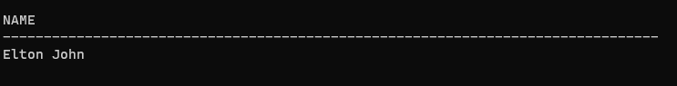

**b.Find the trackTitles of the “gold” certified albums.**

**Solution:**

SELECT trackTitle FROM Track INNER JOIN Album ON Track.albumID = Album.albumID AND Album.certification = 'Gold';

**Output:**

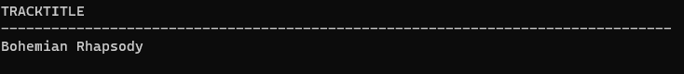

**c. Find the average numberOfTracks from all the albums whose artist is at least 30**

**years old.**

**Solution:**

ELECT AVG(numberOfTracks) as average_tracks

FROM Album

WHERE artistID IN (

SELECT artistID

FROM Artist

WHERE age >= 30

);

**Output:**

